Research Grant for Sustainable Development Goals
(RG-SDGs)-2020

Research Proposal / Application

<Project Title>
<submitted by/affiliation>

Read carefully before filling the form:

- Please do not alter the layout of the application form. Information must be filled in the spaces provided, under set format.
- Please attach required letters with the proposal where applicable such as endorsement letter, board approval letter, consent letter
- Guidance notes in various fields should not be deleted.
- Required information should be duly filled in the specified fields.
- Required heads/fields which are not relevant to the project should be marked N/A (Not Applicable) or left blank and should not be deleted.

Guidelines: Application for Research Grant for Sustainable Development Goals (RG-SDGs)

Introduction
Research Grant for Sustainable Development Goals RG-SDGs is supported by Planning & Development Department (P&DD), Government of Balochistan and UNDP under Balochistan SDGs Accelerated program as an innovative approach to accelerate progress on SDGs in Balochistan. Research Grant for Sustainable Development Goals (RG-SDGs), is dedicated to create sustainable innovation centric research and development ecosystem, compatible to knowledge economy of Balochistan, Pakistan.

The main goals of RG-SDGs are much analogous to those of SDGs i.e., to

- Build and strengthen awareness and capacity among young researchers to contribute in achieving SDG agenda
- Stimulate the development of analytical tools for solving SDG challenges

The RG-SDGS will be continued source to promote sustainable Science and Technology (S&T) development, entrepreneurship, commercialization, to strengthen departmental/institutional research laboratory, to enhance the capacity of research units within departments/institutes, capacity building and contributing to develop sustainable knowledge economy. The RG-SDGS, promotes the view that only sustainable incremental innovative research can improve the research culture at UoB and Balochistan. We encourage proposals that perform original research as well as leverage results of existing research to develop sustainable solutions for important industrial, commercial and social problems align with Sustainable Development Goals SDGs. Funded proposals are expected to perform research and development that leads to innovation and resulting knowledge economy in the university as well as in the province.
RG-SDGS is intended to provide research grant to PhD and MPhil Research scholars/students of UoB where personal or departmental resources have been exhausted or deficient. RG-SDGs funds will be provided to the registered graduate students and research group for research project which may incorporate two or more departments through new collaborative Initiative, creating sustainable entrepreneurial opportunities and exploring interdisciplinary domains, virtuously aligned with SDGs.

Submission Procedure
Duly filled application forms (hard copy) complete in all respects along with any documents should be submitted to ORIC-UoB office and soft copy via portal/email to oric.uob@gmail.com . On receipt of the applications, the proposals will be evaluated internally as well as externally as described in guidelines and procedure document. A written agreement will be made between ORIC-UoB/UNDP and PI, the PI will undertake to administer the grant according to the agreement and to provide laboratory space, and other facilities necessary for the project.
Application for Research Grant for Sustainable Development Goals RG-SDGs

Section – 1

1.1 Project ID
Project Title:
<type here>

Principal Investigator (PI):
Name:
Designation/Status:
Department:
Cell # : |  |  | Tel. # :
Email:
Program | MPhil MS PhD |  |  | Session:
Thesis Title:
ASR&B Meeting Number, Date of approval (In case synopsis not approved, please submit endorsement letter dully signed by prospective supervisor and DAC)
Co-Principal Investigator (CPI):
Name:
Designation/Status:
Department:
Mobile # : |  |  | Tel. # :
Email:
Key Words: (Please provide a maximum of 5 key words that describe the project.)
<type here>

Project Status: (Please mark )
❑ New  Modification to previous Project
❑ Extension of existing project

Project Duration: |  | months
Proposed Budget: |  | PKR
Executive Summary and objectives alignment with SDGs/target(s)/indicator(s) : (Brief description of the project. A non-technical summary of the proposal, its impact and results in the light of SDGs. Maximum 500 words.)
<type here>

Section – 2

2.1 Background
Scope of the Project:
<type here>

Literature Review: (Detailed summary of what all has been done internationally in the proposed area quoting references and bibliography. Maximum 1500 words.)
<type here>

Current State of the Art: (Please describe the current state of the art specific to this research topic. Maximum 500 words.)
<type here>

Challenges: (Please describe the challenges, specific to this research topic, currently being faced internationally. Maximum 500 words.)
<type here>

Motivation and Need: (Please describe the motivation and need for this work. Maximum 500 words.)
<type here>

2.2 Outcomes and Benefits
Expected Outcomes: (Provide a list of proposed project outputs including publications, databases etc.)
<type here>

How these outcome(s) are aligned with Goal(s)/target(s)/indicator(s) of SDGs: (Please identify clearly that how your project outcome are aligned with Goal(s)/target(s)/indicator(s) of SDGs)
<type here>

Technology Transfer/Diffusion Approach: (Please describe how the outputs of the project will be transferred to the beneficiaries/customers. Maximum 500 words.)
<type here>

2.3 Objectives
Research Objectives:
<type here>

Alignment of Objectives with SDGs/target(s)/indicator(s):
<type here>

2.4 Research Approach
Development / Research Methodology:
(Please describe the technical details and justification of your development and research plan. The block diagrams, system flow charts, etc. may be provided in this section. Maximum 3000 words.)
<type here>

Key Milestones and Deliverables:
(Please list and describe the principal milestones and associated deliverables of the project. The timing of milestones is also to be shown in the Gantt chart in Annexure-A. Quarterly deliverables are preferred.)
The information given in this table will be the basis of monitoring and release of funds by the National ICT R&D Fund.
No. |  | Elapsed time from start (in months) of the project |  | Milestone |  | Deliverables
 | 3 months
 | 6 months
 | 9 months
 | 12 months
(Please add more rows if required.)

2.5 Risk Analysis
(Please list the risks that may cause delays in, or prevent implementation of, the project. For each risk estimate the likelihood, likely impact/consequences on the project and steps to minimize/avoid the risk.)
Risk | Likelihood  (Low, Med, High) | Impact | Mitigation
Technical Risk
Budget Risk

Section – 3

3.1 Resources & Other Requirements
Project Team:
(Please attach the CVs of PI, CPI(s) and key research/development personnel which should clearly show their expertise in relation to the needs of the project.)

Title/Position  (of each member) | Role/Key Responsibilities | Minimum Qualification | Expertise / Background | Minimum Experience (years)

3.2 Departmental Endorsement
Ownership of Equipment/Kit/Chemical etc.:
All newly purchased or developed equipment, kits, chemical etc., from this project shall be under the ownership of department and declared as UoB property. Moreover, any concerned scholar, faculty member of the university can use it after the completion of the project.

Head of the Department of the Principal Investigator:
( Please attach support letter that required items for this project are necessary for this research and does not exist/available in university)
Name:
Designation & Department:
Email:
Date: |  |  | Signature  & stamp:

Annexure–A: Project Schedule / Milestone Chart

(Project schedule using MS-Project (or similar tools) with all tasks, deliverables, milestones, alignment with SDGs, cost estimates, payment schedules clearly indicated are preferred.)

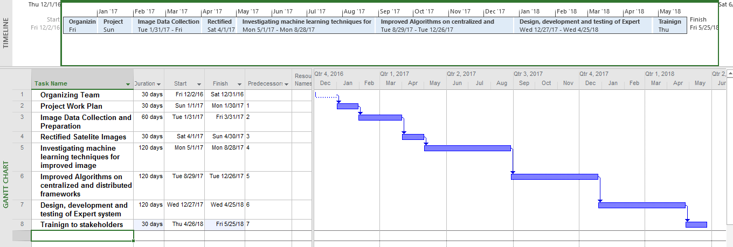

Annexure–B: Proposed Budget

Annexure–A: Curriculum Vitae

Please provide relevant information and also attach CVs of key research / development personnel (if available) and PI, CPI.
- Professional Information
- Name :
- Title or Position Held :
- Experience (yrs)
- Email Address :
- Research Papers in Relevant Area
<type here>

- Courses Studied in Relevant Area
<type here>

- Thesis / Projects in Relevant Area
<type here>

- Grants Received in Relevant Area
<type here>

- Industrial Work Done in Relevant Area
<type here>

Please paste detailed CV here

Bibliography

<type here>

